TK-STAR GPS TRACKER USER MANUAL

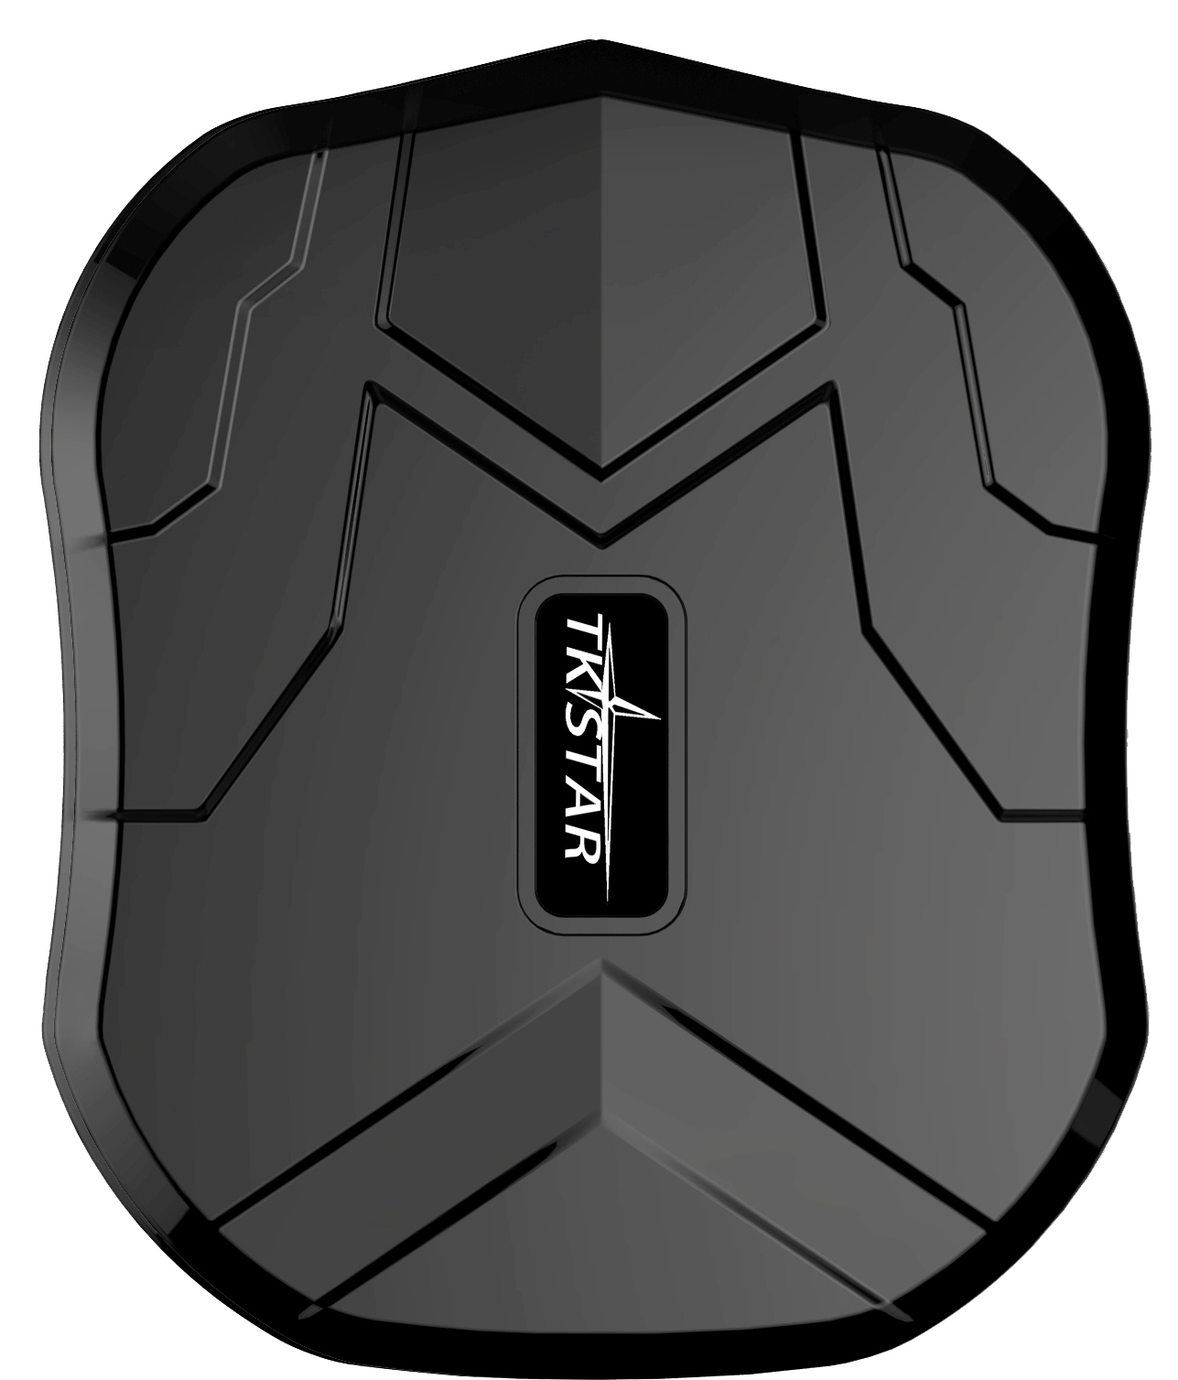

PREFACE

Thank you for purchasing TKSTAR GPS tracker. This manual shows how to operate the device smoothly in details, please make sure to read this manual carefully before using the device. Please be noted that any update of the manual is made without prior notice. Each time the update of the manual will be released in the latest product sales. The manufacturer won’t assume any legal responsibility for any errors or omissions made in this manual.

1 SUMMARY
Working based on existing GSM/GPRS network and GPS satellites, this product can locate and monitor any remote targets by SMS, APP and Internet. It adopts the most advanced technology of GPS and AGPS dual positioning.

Content | Specs.
Dim. | 90mm x 72mm x 22mm(3.5”*2.8”*0.8”)
Weight | 168g
Network | GSM/GPRS
Band | 850/900/1800/1900Mhz
GPS sensitivity | -159dBm
GPS accuracy | 5m
Wall charger | 110－220V input  5V-1A output
Battery | Chargeable 3.7V 5000mAh Li-ion battery
Stand by | 90days
Time To First Fix | Cold status 45s  Warm status 35s  Hot status 1s
Storage Temp. | -40°C to +85°C
Operation Temp. | -20°C to +55°C
Humidity | 5%--95% non-condensing

2.Hardware Description
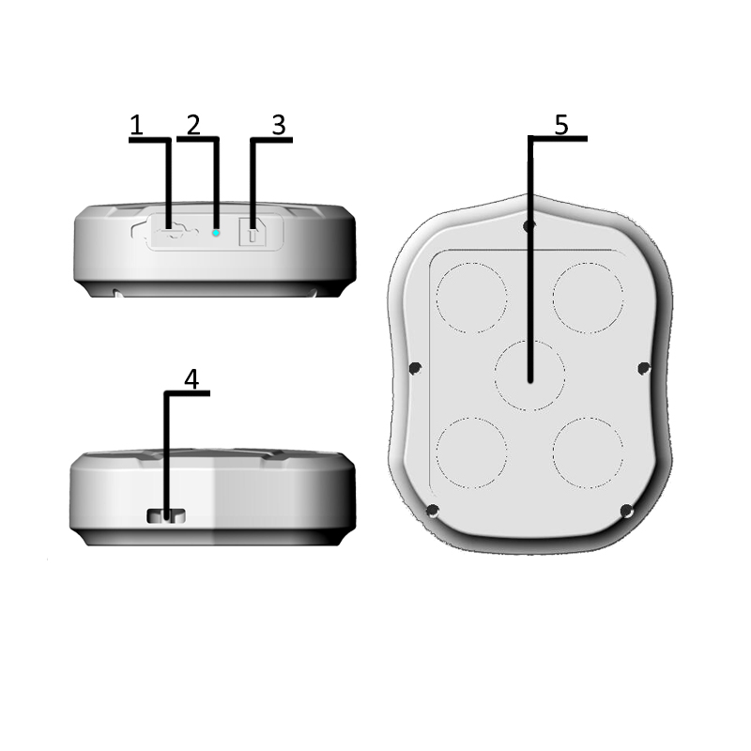
1. USB port 2. Indicator light 3. SIM card slot
4. Lanyard hole 5. Strong Magnet

INDICATOR LIGHT STATUS | MEANING
Yellow light -Solid | No GPRS signal
Yellow light -Flash | GPRS connection
Blue light -Solid | No GPS signal
Blue light -Flash | GPS connection
Note: GSM SIM CARD INSTALLATION GUIDE: Only GSM SIM card works in this model
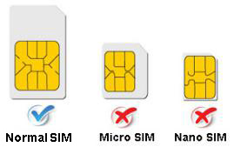
3.TURN ON THE DEVICE
- Open the rubber cover, insert the SIM card(chip up) to the slot.
- The indicator light is on when SIM card is inserted.
- The device gets GPS location when there is GPS signal and gets LBS location when there is no GPS signal.
- The device automatically turns off when the SIM card is removed.

- SMS TRACKING
4.1. Call the SIM card phone number in tracker,you will receive a Google Maps link of position,
or sending message “G123456#” to SIM card phone number in tracker .
E.g:
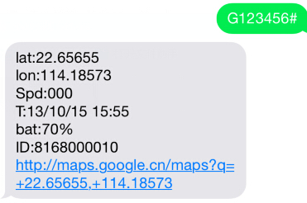

4.2. Admin number setting (After admin number setting, all SMS operations to the device are under this number only.)
Command: admin123456 phone number（This phone number is your own mobile phone number , not the SIM card number in tracker .）
Reply：admin ok
E.g：admin123456 13265790180
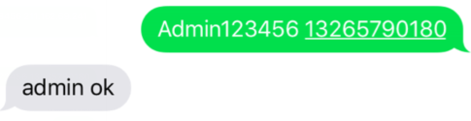
When the unit is in over-speed alarm, shake sensor alarm, or low battery alarm, it will send alert to the admin number.（13265790180）
Admin number Canceling:
Command ：noadmin123456
Reply：noadmin ok

4.3. Over-speed Alarm setting（It works only in continuous positioning mode.）
Over-speed Alarm setting:
Command ：speed123456 070（Suppose speed is 70km/h）
Reply：speed ok
E.g：
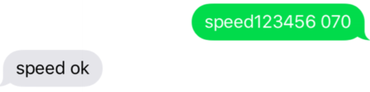
When the unit speed is over 70km/h, it will send message “speed alarm!” to the admin number every 5 minutes.
Over-speed Alarm canceling ：
Command ：nospeed123456
Reply：nospeed ok

4.4. Shake Alarm setting
Command：shock123456
Message Reply：shock ok
E.g：

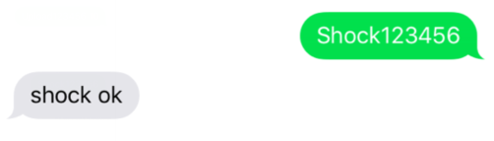
Note:Pls keep the tracker being stationary for 5 minutes, this function will work.
The tracker will send SMS “sensor alarm!” to the admin number when the unit get shocked.
Shake alarm Canceling:
Command：noshock123456
Reply：noshock ok

4.5. Device working mode setting
Sleep by time mode setting：
Command：sleep123456 time
Reply：sleep time ok
E.g：


(Tracker only works for 5 minutes after being waked up, and back to sleep mode, GPS shut off, GSM works in low consumption mode. SMS command, calling tracker can wake up the tracker.)

Sleep by shock sensor mode setting: (Factory setting is “Sleep by shock mode“)
Command：sleep123456 shock
Reply：sleep shock ok
E.g：

(No shock for 5 minutes, the tracker will work in “sleep by shock” mode, GPS shut off, GSM works in low consumption. Vibration, SMS, calling can wake up the tracker.)

4.6 Terminal (local) Time Setting(factory setting GMT 0)
Command：timezone123456 local time zone
Reply：time ok!
E.g： timezone123456 +1 timezone123456 -1 Timezone123456 0
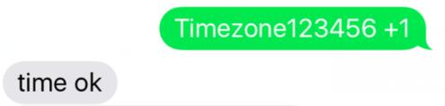
4.7Reset Hardware
Command：begin123456
Reply：begin ok
E.g：


5. EXPLANATION OF PARAMETERS/CODES IN SMS MESSAGE
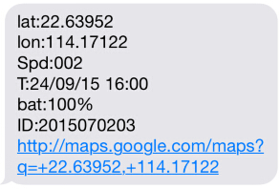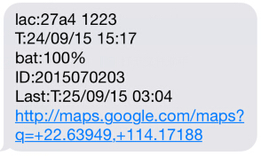
Pic（1） Pic（2）

Pic 1：Replied real-time tracking information under GPS satellites signal.
- Lat:22.63952 lon:114.17122 Positioning of the latitude and longitude values.
- Spd：000 This refers to the device moving speed. The unit is km/h.
- T:24/09/15 16:00 real-tracking time, the Default is London time. You can set language and time zone in APP.
- Bat：100% The battery value is between 10% and 100%. Once it is less than 30%, it alarms.
- 2015070203: Device IMEI No. to log in APP and platform.
- Google Link: This is the link to the Google map showing the position of the device.

Pic 2：Replied LBS tracking information without GPS satellites signal.
- Lac:27a4 1223: Real-time LBS positioning data.
- T:24/09/15 15:17 LBS positioning time.
- Bat：100% The battery value is between 10% and 100%. Once it is less than 30%, it alarms.
- Last：T:25/09/15 03:04 This is the time when tracker got last GPS signal
Google Link： This is the position of last gps signal appeared

6. 0 START ONLINE TRACKING
Pls activate GPRS by sending command “gprs123456” when the tracker is on, and set APN by following steps.
Every sim card carrier has own APN content, we have two methods to find out apn content : check sim card carrier on internet or put sim card into cell phone to find out APN
Two steps to set apn:
1), Turn on gprs function by sending command “gprs123456”
2),Set apn by sending command “apn123456 content” , “apnuser123456 content” ,“apnpasswd123456 content” pls note the content is from SIM card carrier , there is small blank after 123456 in every command.

6.1 WEB ONLINE TRACKING

Platform : www.mytkstar.net
Select “Log in by IMEI” on the bottom of screen

IMEI No. : on the back side of cover
Password: 123456

6.2 APPLICATIONS FOR ANDROID/iOS
Search “TKSTAR GPS“ in the Apple App Store/Google Play
Store or Scan the QR Code to install the applications on
your cell phone.

Select “Log in by IMEI” on the bottom of screen

Server: www.mytkstar.net

IMEI : on the back side of cover
Password: 123456

6.3 Turn on GPRS function by sending command “GPRS123456” to the tracker, and set the APN for the tracker, then its online tracking by APP and platform works. (if you did it already in 6.0, no need to it one more time )

COMMAND INSTRUCTION TO SET APN

INSTRUCTION | COMMAND | REPLY
Turn on GPRS | GPRS123456 | GPRS OK
Set APN  ( any existing will be replaced) | apn+123456+space+apn content | apn ok
Set APN username | apnuser+123456+space+content | apnuser ok
Set APN password | apnpasswd+123456+space+content | apnpasswd ok

E.g:

For tesco mobile SIM card in UK, we got APN information below.
APN name:prepay.tesco-mobile.com
APN username:tescowap
APN password:password

Send SMS to set apn below
1. gprs123456
2. apn123456 prepay.tesco-mobile.com
3. apnuser123456 tescowap (no need to set if without apnuser)
4. apnpasswd123456 password (no need to set if without password)
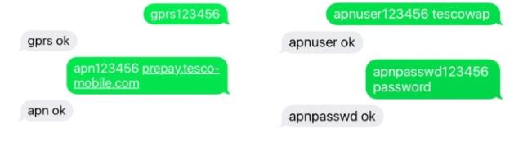

7. Notices:
1.GPS tracking can be worked outdoor.
2.Please make sure GSM SIM card supports making calls, sending messages, GPRS network.
3.Please make sure GSM SIM card is with sufficient balance.
4.Please make sure the GSM card has opened the call shows and turned off the call transfer.
5.Please insert the GSM phone card correctly.
6.Do not assembly and disassembly device at will.
8. FAQ and processing methods.
FAQ | Instructions/Solutions
Fail to turn it on | Please check if battery is charged
No GSM signal | - Please check if SIM card installed correctly.  - Please check if SIM card is GSM network.  - Don’t turn on the PIN code  - no calls can be diverted  - Please check if voltage of the power is normal  - Please check if voltage of the power is normal  电源电压是否正常
No GPS | A more open view of the sky is recommended to make sure the device can receive the GPS signal normally.
No reply to SMS command | Password wrong or the format is wrong.
No reply to calling & No alarm message | Authorized / admin phone number is incorrect or has not setup
SMS position OK, cannot use the APP and web platform | Pls check if APN is correctly set. And pls find out the correct APN content of the SIM card. (Pls refer to 6.3 setting.)
Platform position is difference from the actual position. | No uploading position time or no GPS signal: call the device phone number and receive the position message. If it shows like Pic 2, it means no GPS signal. The position is the last GPS positioning location; If it shows like Pic 1, it means the device doesn’t reach the uploading time.

